**Linking Excel Objects in Word**

**Step 1:** Open data-in-word-example-workbook in Excel and Enable Editing.



**Step 2:** Open a blank Microsoft Word document.

**Step 3:** In Excel, copy the small table. To do this select the cells, right-click and select copy (or Ctrl + c).

**Step 4:** In the Microsoft Word document, click the **Home** tab. Then navigate to the left corner and select the down arrow on the **Paste** icon.



**Step 5:** Now select **Paste Special**.



**Step 6:** In the resulting pop-up window, click on **Microsoft Excel Worksheet Object** and **Paste link** then click **OK**. (If Paste link is not available, 1. Make sure you have enabled editing on the Excel worksheet. 2. Make sure you have copied the correct cells.)

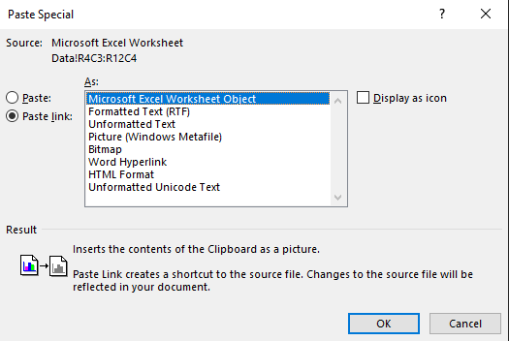

**Step 7:** You will now see a table.



**Step 8:** Now go back to Excel and change some values.

**Step 9:** In Word, right-click on the pasted table and select Update Link. The values in Word should change to match the values in Excel.

